Installing WordPress in Azure

Here is how I have installed WordPress on Ubuntu Linux Apache server running on Azure Virtual Machine.
Steps followed are as follows:
- Create a resource group
- Create a VNET with 3 subnets (web, application & database: this is optional as I have created this for future ref of HA and 3 tier architecture design in mind. One will be suffix at this stage)
- Create an Ubuntu Virtual Machine
- Connect to Ubuntu Server using SSH
- Install Apache2 HTTP server
- MySQL Installation and Configuration
- Install PHP and Related Modules
- Create the WordPress Database
- Download and Install WordPress

- Create a resource group: created a new resource group to manage all the resource under this small project.
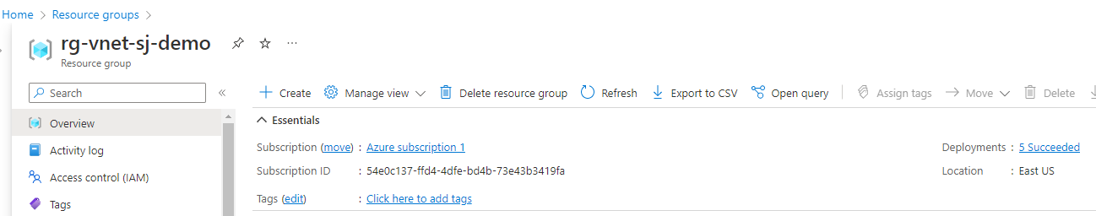

- Create a VNET with 3 subnets: I have created a vnet with 4 subnets as follows:
    - VNET: 10.16.0.0/16
      - suba-web-sj-demo-0011: 10.16.16.0/20
      - subb-app-sj-demo-0011: 10.16.32.0/20
      - subc-db-sj-demo-0011: 10.16.48.0/20
      - subhub-sj-demo-0011:10.16.176.0/20
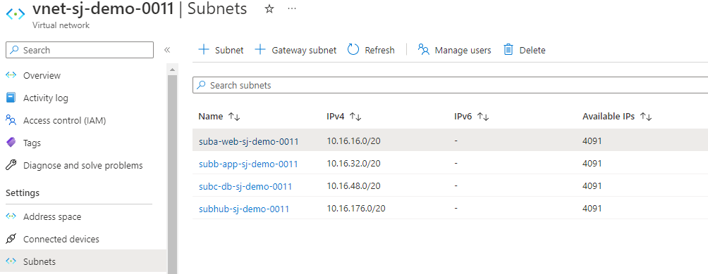
- Create an Ubuntu Virtual Machine: For Image, I choose Ubuntu Server 20.04 LTS – Gen 2 and choose the size as per the requirement.

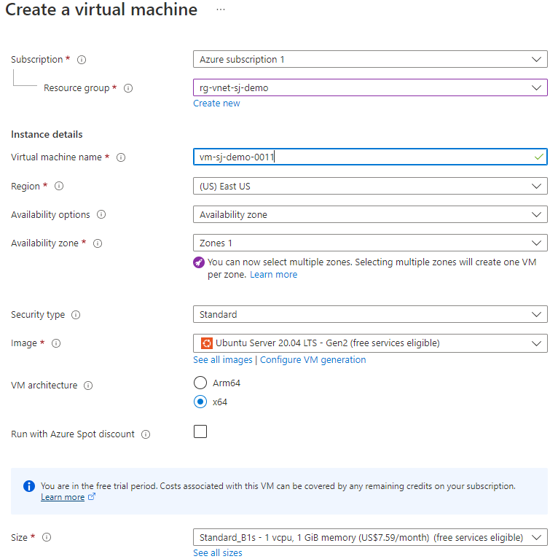
Under Administrator account, selected SSH public key as Authentication type
In Username, I have given my chosen one.
For SSH public key source, I have selected use existing key and chose the stored key from the drop-down menu. If you don’t have any, leave it default, and then type the key name for the Key pair name.
Under the Public inbound ports, I have selected Allow selected ports and then SSH (22) and HTTP (80) from the drop-down.

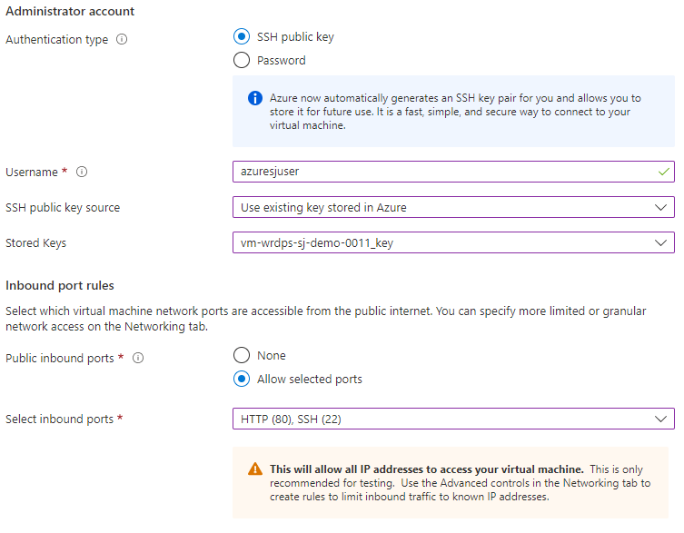
In the Networking tab, I have enabled “Delete public IP and NIC when VM is deleted” to avoid any unnecessary billing shock.
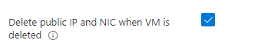
Leaving everything else as defaults, click on Review + create. If it is still asking for some details, fill that and hit Create.
A new popup will show up if you choose to generate a private key and select Download private key and create resource. The key file will be downloaded as thekeyname.pem. This file needs to converted to .ppk if Putty is used for connecting to the vm.
Once it is deployed, the Public IP address of the VM needs to be noted.
I didn’t use my own DNS for this basic setup and go with default setup.
- Connect to Ubuntu Server using SSH: I have used Putty to connect to ubuntu server.
Configure Putty as follows:

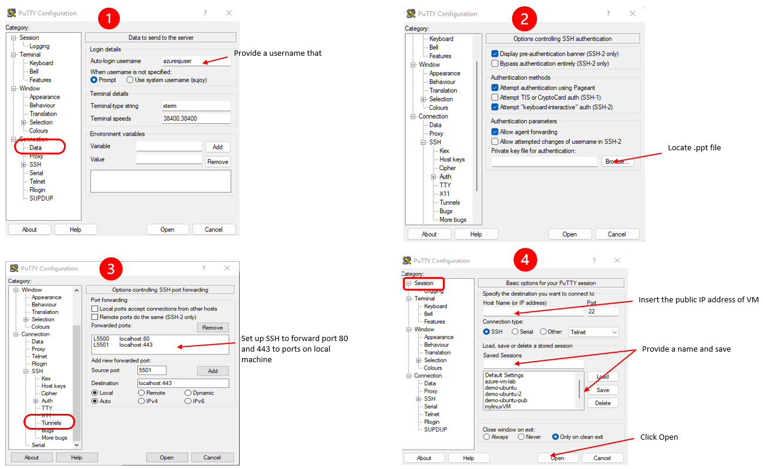

- Install Apache2 HTTP server:
I am using Apache2 HTTP server, and to install it, run the following command:
sudo apt update
sudo apt upgrade
sudo apt install apache2

Entered the following command to ensure that Apache2 Service starts automatically after a reboot.
sudo systemctl stop apache2.service
sudo systemctl start apache2.service
sudo systemctl enable apache2.service

Now, it’s been installed, to check if the web server is working or not, we can Go to the browser and visit the public IP address/localhost:5500. The page should be looking as below:
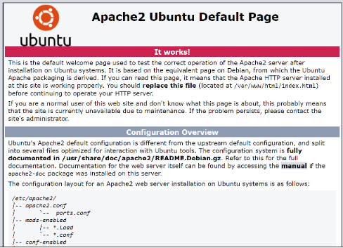
- MySQL Installation and Configuration:
WordPress requires a database to store its contents. I am using MySQL for it and to install the MySQL database server, run the following command:
sudo apt install mysql-server

Entered the following command to ensure that MySQL Service starts automatically after a reboot.
sudo systemctl stop mysql.service
sudo systemctl start mysql.service
sudo systemctl enable mysql.service

MySQL Configuration
Now, to perform a secure install for MySQL, lets configure the security options by executing the following command: *** Please read this section before running this command
sudo mysql_secure_installation

*** Warning: As of July 2022, an error will occur when you run the mysql_secure_installation script without some further configuration. The reason is that this script will attempt to set a password for the installation’s root MySQL account but, by default on Ubuntu installations, this account is not configured to connect using a password.

Prior to July 2022, this script would silently fail after attempting to set the root account password and continue on with the rest of the prompts. However, as of this writing the script will return the following error after you enter and confirm a password:
... Failed! Error: SET PASSWORD has no significance for user 'root'@'localhost' as the authentication method used doesn't store authentication data in the MySQL server. Please consider using ALTER USER instead if you want to change authentication parameters.

This will lead the script into a recursive loop which you can only get out of by closing your terminal window.

Because the mysql_secure_installation script performs a number of other actions that are useful for keeping your MySQL installation secure, it’s still recommended that you run it before you begin using MySQL to manage your data. To avoid entering this recursive loop, though, you’ll need to first adjust how your root MySQL user authenticates.

First, open the MySQL prompt:
sudo mysql

Then run the following ALTER USER command to change the root user’s authentication method to one that uses a password. The following example changes the authentication method to mysql_native_password:
mysql> ALTER USER 'root'@'localhost' IDENTIFIED WITH mysql_native_password BY 'password';
After making this change, exit the MySQL prompt:
mysql> FLUSH PRIVILEGES;
mysql> exit;

Following that, you can run the mysql_secure_installation script without issue.

Enter the following settings:

Enter current password for root (enter for none): Just press the Enter
Set root password? [Y/n]: Y
New password: Enter password
Re-enter new password: Repeat password
Remove anonymous users? [Y/n]: Y
Disallow root login remotely? [Y/n]: Y
Remove test database and access to it? [Y/n]: Y
Reload privilege tables now? [Y/n]: Y

So, to test if the setup is successful, enter the following command:
sudo mysql -u root -p
Enter your password, and it should login you to the mysql console.
Here, we can type ‘exit’ to exit out of the session.

- Install PHP and Related Modules
Run the following command to install PHP and related modules:
sudo apt install php php-mysql php-cgi php-cli php-gd
To restart the Apache2 server.
sudo systemctl restart apache2

- Create the WordPress Database
Login to MySQL and enter your password:
sudo mysql -u root -p
Then create the database wordpressdb:
CREATE DATABASE wordpressdb;
SHOW databases;
After that, create a database user, wpuser with new password.
CREATE USER 'wpuser'@'%' IDENTIFIED BY 'your_password_here';
Grant the user full access to the database.
GRANT ALL PRIVILEGES on wordpressdb.* to "wpuser"@"%";
FLUSH PRIVILEGES;

- Download and Install WordPress
Now to get the latest release of WordPress, I run the followings
wget https://wordpress.org/latest.zip
It should download the latest WordPress release zip file.
Now need to install unzip and unzip the file.
sudo apt install unzip
unzip latest.zip
Now, copy all its content to the new directory, to keep the contents of the website.
cd wordpress
sudo cp -r * /var/www/html/
After that, set the correct permissions for WordPress directory files.
cd /var/www/html/
sudo chown -R www-data:www-data /var/www/html/
sudo chmod -R 755 /var/www/html/

And, delete the default index.html file.
sudo rm -rf index.html

Now, if I go to a browser and enter Public IP Address/ localhost:5050, then the WordPress Installation page should appear.
